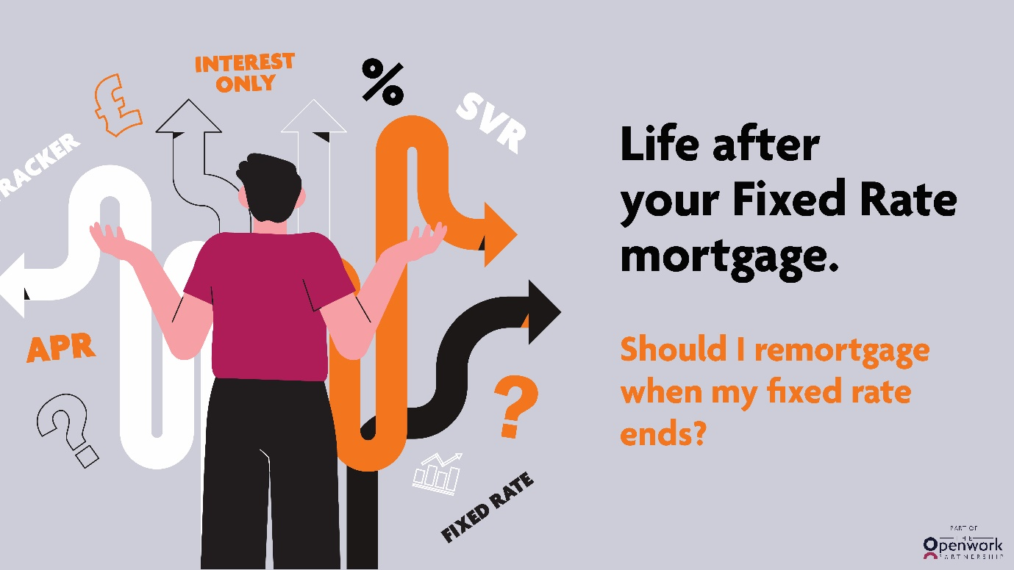

Life after your Fixed Rate mortgage.
Should I remortgage when my fixed rate ends?

The short answer? Yes. If you don’t remortgage at the end of your term, you will be automatically transferred to your lender’s standard variable rate, which tends to be higher than the rates on most other mortgage options.*
So if you’re coming to the end of your fixed rate mortgage deal, it’s worth shopping around to see which remortgage option suits you and your unique needs – it may not be the one you think!

To fix your rate or not, that is the question.

If you’re currently on a fixed rate mortgage (unsurprisingly, as they are the most popular mortgage at the moment)* you might be thinking that another fixed rate mortgage is the obvious choice when your current one ends.

It’s understandable to see why. Fixed rate mortgages give borrowers stability – you know exactly how much you’re paying each month, for a set period of time, and can budget accordingly.

And after over a decade of low interest rates, fixed-term mortgage deals have become the go-to for many homeowners. However, this doesn’t necessarily mean they are the right choice for everyone.

There are plenty of other mortgages on the market, such as life-time trackers, green mortgages, or offset mortgages. And until you delve a little deeper, you might not be able to make an informed choice. An expert mortgage adviser can help you do just that.
Spotlight on the tracker mortgage: the flexible option
One of the mortgage options on the market is a tracker mortgage – a mortgage that follows the Bank of England Base Rate, usually with a fixed percentage added on top. If the Base Rate drops, so will the mortgage rate, and vice versa.
A key benefit of a tracker mortgage is flexibility. When it comes to fixed rate mortgages, lenders will review the lending market over a specific timeframe. Then they’ll work out what they believe will be the average lending rate over that period. After they have acquired that fixed price, they will pass it onto fixed rate products.
However, tracker products cut out the need to predict, as they follow the Bank of England Base Rate in real time. Unlike a fixed rate mortgage, the amount you pay per month could change, as the mortgage ‘tracks’ the Base Rate over two or three years. As a result of this, we sometimes see lenders price their tracker products much more competitively than their fixed rate options.
The pros and cons of a variable rate
The competitive pricing on tracker mortgages may make them cheaper than their fixed rate counterparts, especially if you’re coming to the end of your fixed rate term and you’re faced with a higher interest rate than you were expecting.
Tempting as this is to switch to a tracker with a lower rate, it’s crucial to make sure you can afford to pay your monthly repayments if the rate goes up in future!
It’s also worth bearing in mind that there are some tracker mortgages that don’t have an early repayment charge, so you are free to leave without penalty. However, this is not the case for all of them, so consider which product you choose carefully, as you may have to pay a penalty fee for leaving early.
Plan your next remortgage steps with an adviser from Finhawk Mortgages Ltd
If you are unsure about remortgaging, seek mortgage advice from an expert. We have our fingers on the pulse of the mortgage market and are equipped with in-depth knowledge of the different mortgage products on offer. Our insider knowledge can make your remortgaging process simple, so are you ready to find the right mortgage for you? Speak to us today.
Call David on 07774 127179 or drop us an email on dbeach@finhawkmortgages.co.uk
Your home may be repossessed if you do not keep up repayments on your mortgage.

Approved by The Openwork Partnership on 27/04/23

